### **ANTI-SLEEP ALARM FOR DRIVERS**

**ABSTRACT**

With the predictions of World Health Organization (WHO) that the number of deaths due to traffic accidents will be around 2 million within less than 15 years, researchers nowadays are paying more attention to how to help in preventing traffic accidents and lower the number of occurred fatalities. The purpose of this study is an attempt to prevent traffic accidents due to fatigue or sleepiness. In this report, a portable and low cost device for prevention of accidents that happen because of sleepiness or fatigue. The proposed sensors mounted on eyewear. Depending on the reflected and absorbed IR radiation, this system detects and classifies the eye blinking into normal blinking (NB).

**Table Of Contents**

|  |  |  |
| --- | --- | --- |
| **SR. NO.** | **NAME** | **PAGE NO.** |
| **CHAPTER NO. 01** | **INTRODUCTION and PROBLEM STATEMENT** | **1** |
| **CHAPTER NO. 02** | **OBJECTIVES** | **2** |
| **CHAPTER NO. 03** | **MOTIVATION** | **3** |
| **CHAPTER NO. 04** | **CIRCUIT DIAGRAM** | **4** |
| **CHAPTER NO. 05** | **COMPONENTS** | **5** |
| **CHAPTER NO. 06** | **ADVANTAGES**  **and DISADVANTAGE** | **12** |
| **CHAPTER NO. 07** | **FUTURE SCOPE** | **15** |
| **CHAPTER NO. 08** | **CONCLUSION** | **16** |
| **CHAPTER NO. 09** | **REFERENCES** | **17** |

## CHAPTER NO. 1

**INTRODUCTION AND PROBLEM STATEMENT**

Driving fatigue, alcohol consumption, and engine overheating are significant contributors to road accidents worldwide. In response to these dangers, the development of advanced safety systems has become imperative.

The Anti-Sleep Alarm for Car Drivers based on Arduino presents sophisticated solutions designed to enhance road safety by addressing these critical issues. This innovative system integrates cutting-edge technology with the ubiquitous Arduino platform to provide real-time monitoring and intervention capabilities. By leveraging sensor data and intelligent algorithms, it can detect driver drowsiness, alcohol consumption, and engine overheating, thereby mitigating potential risks on the road.

# Problem Statement

Despite increased awareness of the dangers of drowsy driving, it remains a significant cause of accidents, injuries, and fatalities on the roads. Traditional approaches to address drowsy driving, such as education ,campaigns and regulations, have limitations in effectively preventing incidents in real-time. There is a pressing need for an innovative solution that leverages IoT technology to detect and mitigate drowsy driving risks promptly .To address this challenge, the project aims to develop an anti-sleep car alarm system based on IoT principles.

The system will utilize sensors and data analytics to monitor driver behavior and physiological indicators in real-time. By detecting signs of drowsiness, such as eye closure , the system will trigger timely alerts to warn the driver and prompt them to take corrective action, thereby preventing potential accidents caused by drowsy driving. The goal is to enhance road safety and reduce the incidence of drowsy driving-related accidents through proactive intervention and alert mechanisms enabled by IoT technology

1

# 

# Chapter No. 2

### **ABSTRACT**

With the predictions of World Health Organization (WHO) that the number of deaths due to traffic accidents will be around 2 million within less than 15 years, researchers nowadays are paying more attention to how to help in preventing traffic accidents and lower the number of occurred fatalities. The purpose of this study is an attempt to prevent traffic accidents due to fatigue or sleepiness. In this report, a portable and low cost device for prevention of accidents that happen because of sleepiness or fatigue. The proposed sensors mounted on eyewear. Depending on the reflected and absorbed IR radiation, this system detects and classifies the eye blinking into normal blinking (NB).

## OBJECTIVES

Road safety remains a critical concern, with driver fatigue, alcohol consumption, and engine overheating posing significant risks to both drivers and pedestrians. This paper presents the development of a multifunctional

anti-sleep alarm system designed to mitigate these risks. The system utilizes Arduino microcontroller technology to monitor driver behavior and vehicle conditions in real-time. The proposed system incorporates several key features to enhance safety.

Firstly, an anti-sleep alarm mechanism detects signs of driver drowsiness by analyzing steering patterns and vehicle dynamics. Upon detecting fatigue, the system triggers an alarm to alert the driver and safely deactivate the car's ignition, preventing potential accidents.

Secondly, the system includes an alcohol detection module, capable of sensing the presence of alcohol in the driver's breath. If alcohol consumption is detected above a predetermined threshold, the system initiates a safety protocol by automatically disabling the ignition, thereby preventing intoxicated driving.

Furthermore, the system monitors the temperature of the car engine using temperature sensors. In the event of engine overheating, the system intervenes by shutting off the ignition to prevent further damage and potential fire hazards, ensuring the safety of both the vehicle and its occupants.

2

**CHAPTER No. 3**

**MOTIVATION**

The motivation behind anti-sleep car alarms is primarily safety. Falling a sleep while driving can have catastrophic consequences, leading to accidents, injuries, and fatalities. These alarms are designed to alert drivers when they show signs of drowsiness or are at risk of falling asleep behind the wheel, thereby helping to prevent accidents and save lives.

Drowsy driving is a significant problem, especially during long trips or late-night drives when drivers may experience fatigue and reduced alertness. According to research, drowsy driving can impair reaction times, attention, and decision-making abilities, making it similar to driving under the influence of alcohol or drugs in terms of its effects on driving performance.

Anti-sleep car alarms typically use various technologies to detect signs of drowsiness or inattention, such as monitoring steering patterns, vehicle movements, lane departures, eye movements, or physiological indicators like heart rate or brain activity. When these systems detect that a driver is becoming drowsy or losing focus, they trigger an alarm or warning signal to alert the driver and prompt them to take corrective action, such as pulling over for a rest or switching drivers.

By alerting drivers to their drowsy or fatigued state, anti-sleep car alarms aim to mitigate the risks associated with drowsy driving and improve overall road safety. These systems can play a crucial role in preventing accidents, reducing injuries, and saving lives by intervening before a driver falls asleep at the wheel and potentially causes a collision.

3

# 

# 

# CHAPTER No. 4

**CIRCUIT DIAGRAM**

# 

**4**



5

In simplest terms, a piezo buzzer is a type of electronic device that’s used to produce a tone, alarm or sound. It’s lightweight with a simple construction, and it’s typically a low-cost product

## 3)BATTERY 9V:



A container consisting of one or more cells, in which chemical energy is converted into electricity and used as a source of power .

## 4)MOTOR:

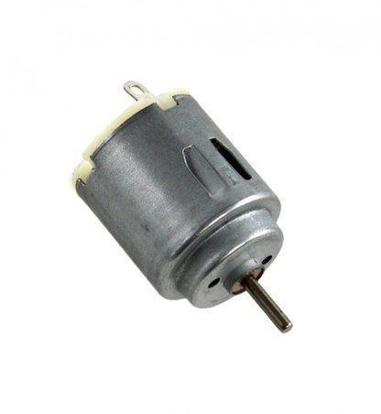

A machine that converts electrical energy into mechanical energy by means of the forces exerted on a current-carrying coil placed in a magnetic field.

## 

**6**

## 5)ARDUINO UNO:

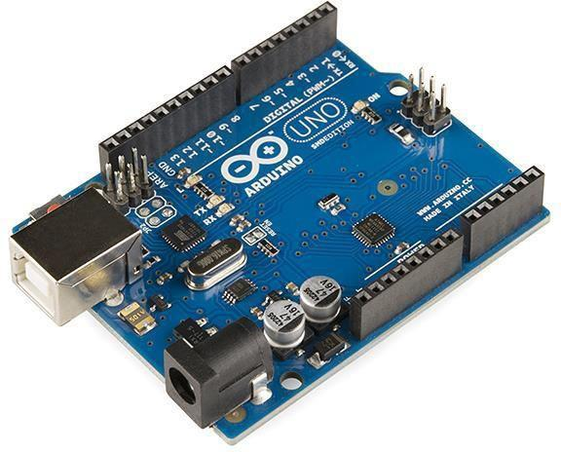

Arduino/Genuino Uno is a microcontroller board based on the ATmega328P. It has 14 digital input/output pins (of which 6 can be used as PWM outputs), 6 analog inputs, a 16 MHz quartz crystal, a USB connection, a power jack, an ICSP header and a reset button.

It contains everything needed to support the microcontroller; simply connect it to a computer with a USB cable or power it with a AC-to-DC adapter or battery to get started.

## 6)EYE BLINK SENSOR:

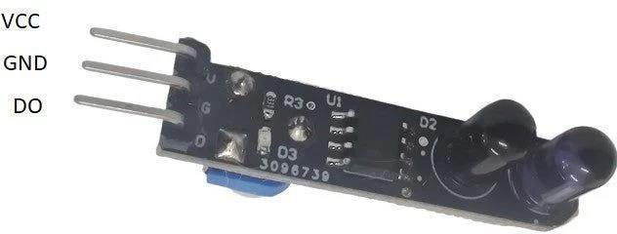

**1. Sensor Module**: The sensor module is the core component responsible for capturing eye movements ,particularly blinks. There are several types of sensors used in eye blink detection, including:

* + - **Optical Sensors**: These sensors use infrared light to detect changes in the reflection pattern caused by

eyelid movement. They can be placed near the eye or integrated into eyewear.

## 7

* + - **Electrodes**: Electrodes placed near the eyes can detect the electrical signals generated by eye movements, including blinks. These electrodes may be dry or require a conductive gel.
    - **Accelerometers**: Accelerometers detect changes in acceleration and can be used to infer eye blinks based on the rapid movement of the eyelids.

**2.Processing Unit**: The processing unit analyzes the data received from the sensor module to determine when blinks occur and extract relevant information. This unit may consist of microcontrollers, digital signal processors (DSPs), or specialized integrated circuits (ICs). The processing unit typically includes algorithms for blink detection, filtering out noise, and interpreting the sensor data.

#### **3.****Additional Components**:

* + - **Power Source**: Eye blink sensors may be battery-powered or have alternative power sources depending on their application and design.
    - **Connectivity**: Some eye blink sensors include wireless connectivity options (e.g., Bluetooth, Wi-Fi) to transmit data to other devices such as smartphones, computers, or wearables.
    - **Integration Interfaces**: Interfaces for integration with other systems or devices, such as microcontrollers, development boards, or wearable technology platforms.
    - **Feedback Mechanisms**: In certain applications, such as assistive devices or human-computer interaction systems, feedback mechanisms like haptic feedback or visual indicators may be included to provide real-time feedback based on blink detection.

#### **4.** **Functionality:**

* **Blink Detection**: The primary function of an eye blink sensor is to detect blinks accurately and reliably. This involves distinguishing between normal eye movements, such as saccades, and actual blinks.
* **Blink Analysis**: Eye blink sensors can provide additional information beyond simple blink detection, such as blink duration, frequency, and patterns.

This data can be useful in various applications, including health monitoring, fatigue detection, and human-computer interaction.

8

## Applications: Eye blink sensors find applications in a variety of fields, including healthcare (e.g., sleep monitoring, neurological assessments), human-computer interaction (e.g., gaze tracking, hands-free control), and assistive technology (e.g., controlling prosthetic devices, aiding individuals with disabilities

## 7)MQ2 SENSOR:

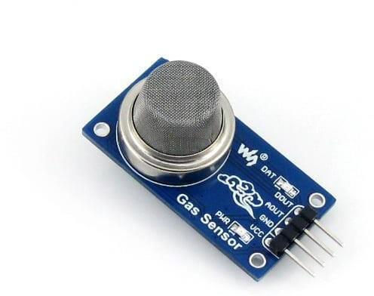

The MQ-2 sensor is a gas sensor module widely used for detecting a variety of gasses, including butane, propane, methane, alcohol, hydrogen, and smoke. It operates based on the principle of gas detection through resistance changes. The sensor consists of a tin dioxide (SnO2) semiconductor sensing material which has low conductivity in clean air but its conductivity increases as the concentration of the target gas increases.

## Operating Principle: The MQ-2 sensor operates on the principle of resistance change in the presence of target gasses. When the sensor comes into contact with a specific gas, the conductivity of its semiconductor material changes, altering the resistance across the sensor's terminals.

* **Construction**: The MQ-2 sensor typically consists of a sensing element, a heating element, and a circuit board. The sensing element is made of tin dioxide (SnO2) semiconductor material, which serves as the gas-sensitive material. The heating element is used to heat the sensing element to a specific temperature, enhancing its sensitivity to gasses.

9

* **Detection Range**: The MQ-2 sensor can detect a wide range of gasses, including LPG (liquefied petroleum gas), propane, methane, alcohol, hydrogen, and smoke. However, its sensitivity to different gasses may vary.
* **Calibration**: Calibration of the MQ-2 sensor is essential for accurate gas detection. Calibration involves exposing the sensor to known concentrations of the target gas and adjusting the sensor's output accordingly.

This ensures reliable detection across various conditions.

* **Output Signal:** The MQ-2 sensor typically provides an analog output voltage that varies with the concentration of the target gas. The output voltage can be interfaced with microcontrollers or other electronic devices for further processing and control.
* **Application**: The MQ-2 sensor finds applications in various fields, including gas leakage detection, industrial safety, environmental monitoring, and fire detection systems. It is commonly used in gas detectors, gas leakage alarms, and gas monitoring systems**.**
* **Limitations:** While the MQ-2 sensor is versatile and widely used, it has some limitations. One limitation is its sensitivity to humidity, which can affect the accuracy of gas detection. Additionally, the sensor's response time and recovery time may vary depending on the target gas and environmental conditions.
* **Precautions:** When using the MQ-2 sensor, it's important to handle

it with care and follow manufacturer guidelines for operation and calibration. Proper ventilation and environmental conditions can also impact the sensor's performance.

10

## 8)TEMPERATURE SENSOR:

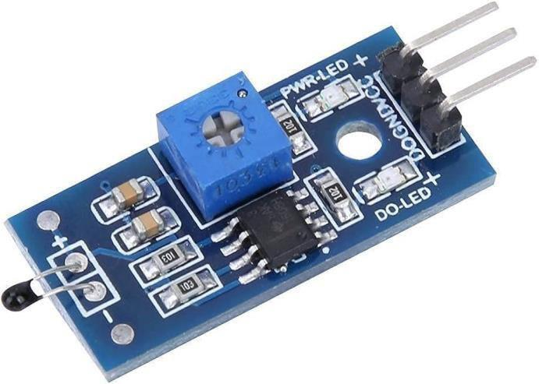

A temperature sensor is a device that measures temperature or temperature changes and converts them into a signal that can be read by an observer or an instrument. These sensors are used in a wide range of applications, from simple household appliances to sophisticated industrial processes.

* **Accuracy**: The accuracy of the sensor is crucial, especially in applications where precise temperature controls are required.
* **Response Time**: Some applications require sensors with fast response times to quickly detect temperature changes.
* **Operating Range**: Sensors should be selected based on the temperature range of the application to ensure reliable performance.
* **Environmental Conditions**: Consideration should be given to factors such as humidity, vibration, and exposure to chemicals or other harsh environments that may affect sensor performance.
* **Cost**: The cost of the sensor should be balanced with its performance and suitability for the application.

11

## CHAPTER NO.6

## 

## ADVANTAGES:

* + **Prevents Accidents**: The primary advantage is that it significantly reduces the risk of accidents caused by drowsy driving. By detecting signs of driver fatigue and automatically turning off the ignition, it helps avoid potentially disastrous situations on the road.
  + **Enhanced Safety**: By incorporating a feature to detect alcohol consumption and disabling the ignition accordingly, the system promotes safer driving practices, reducing the likelihood of drunk driving accidents.
  + **Prevents Overheating Damage**: The ability to shut off the ignition in case of engine overheating prevents potential damage to the vehicle's engine, ensuring its longevity and reducing the risk of roadside breakdowns.
  + **Customizable Alerts**: Depending on the setup, the system can provide customizable alerts to the driver before taking action, such as audible alarms or visual warnings, giving the driver a chance to react and correct their behavior before the ignition is turned off.
  + **Compliance with Regulations**: In regions where regulations mandate the use of safety devices like alcohol detection systems or fatigue monitoring systems, this setup ensures compliance, potentially helping drivers avoid legal repercussions.
  + **Easy Integration**: Being based on Arduino, the system offers flexibility and ease of integration into different vehicle models, making it accessible to a wide range of drivers and vehicle owners.
  + **Cost-Effective Solution**: Compared to proprietary anti-sleep or alcohol detection systems available in the market, a DIY solution based on Arduino can be more cost-effective, making it a viable option for budget-conscious drivers or fleet owners.

12

* + **Promotes Responsible Driving**: Overall, the presence of such a system encourages responsible driving habits among motorists, fostering a safer driving culture and reducing the likelihood of accidents caused by human error or negligence.

## DISADVANTAGES:

* **False Alarms**: The system may trigger false alarms, such as mistaking a tired but awake driver for a sleeping one, or misinterpreting certain driving behaviors as signs of intoxication. This could lead to unnecessary disruptions and frustrations for the driver.
* **Reliability Concerns**: Arduino-based systems are generally reliable, but they can still experience technical issues such as sensor malfunctions or software bugs. If the system malfunctions and disables the ignition when it shouldn't, it could leave the driver stranded, especially in critical situations.
* **Driver Privacy**: Implementing a system that detects alcohol consumption could raise concerns about privacy. Drivers may feel uncomfortable with a device monitoring their alcohol levels, especially if the data is stored or transmitted in any way.
* **Legal Implications**: Depending on the jurisdiction, there may be legal implications associated with implementing such a system. For example, there could be questions about the legality of automatically disabling the car ignition based on alcohol consumption without the driver's consent.
* **Cost and Maintenance**: Installing and maintaining an anti-sleep alarm system with multiple features can be expensive. Additionally, regular maintenance and calibration of sensors may be required to

ensure proper functioning, adding to the overall cost of ownership.

* **User Acceptance:** Some drivers may resist the idea of having their driving behavior monitored or their car controlled by an automated system.

13

* **Dependency on Technology**: Relying too heavily on technology for driver safety can potentially lead to complacency or a false sense of security. Drivers may become less vigilant if they believe the system will always protect them from dangerous situations, which could increase the risk of accidents in

certain scenarios.

* **Compatibility Issues**: Integrating an aftermarket anti-sleep alarm system with existing car systems could lead to compatibility issues or conflicts. Ensuring seamless integration with different car models

and configurations may pose challenges.

* **Limited Effectiveness**: While an anti-sleep alarm may help prevent accidents caused by drowsy driving, it does not address the underlying reasons for driver fatigue, such as inadequate rest or poor

sleep habits. Drivers may still push themselves beyond safe limits, relying solely on the alarm to keep

them alert.

* **Environmental Conditions**: External factors such as extreme temperatures or adverse weather conditions could affect the reliability and accuracy of sensors, potentially leading to false alarms or system failures when they are needed most.

# 14

# Chapter No.7

# Future Scope

* **Integration with Advanced Driver Assistance Systems (ADAS**): Integrating the anti-sleep alarm system with existing ADAS technologies can enhance overall driver safety. This could include features such as lane departure warning, adaptive cruise control, and collision avoidance systems, all working in conjunction with the anti-sleep alarm.
* **Machine Learning Algorithms**: Implementing machine learning algorithms can improve the accuracy of sleep detection and alcohol detection. By continuously analyzing driver behavior and physiological signals (such as heart rate and eye movement), the system can better distinguish between normal driving patterns and instances where intervention is needed**.**
* **Real-time Monitoring and Reporting:** Incorporating connectivity features that allow the system to transmit data in real-time to a central monitoring station or to the driver's smartphone can provide valuable insights. This includes alerting emergency services or designated contacts in the event of an emergency, such as detecting alcohol consumption or driver fatigue.
* **Adaptive Response Mechanisms:** Rather than simply shutting off ignition, the system could employ adaptive response mechanisms based on the severity of the situation. For example, if the driver is showing signs of drowsiness but is still responsive, the system could activate gentle alerts or recommend a break. In more critical situations, such as high levels of alcohol consumption or imminent sleep, the ignition could be immediately disabled.
* **Integration with Vehicle Telematics:** By integrating with vehicle telematics systems, the anti-sleep alarm can access additional data sources such as GPS, vehicle speed, and engine diagnostics. This information can be used to further enhance the system's capabilities, such as providing location-based recommendations for rest stops or preemptively warning of potential engine overheating based on driving conditions.

15

## CHAPTER No .8

**Conclusion**

In conclusion, the Anti-Sleep Alarm for car drivers, built on Arduino technology, offers a comprehensive solution to enhance road safety. By integrating features such as detecting driver fatigue, alcohol consumption, and engine overheating, the system proactively mitigates potential risks associated with drowsy driving, impaired judgment, and mechanical failures.

The implementation of this system not only prioritizes the safety of the driver but also extends its protective measures to other road users, thereby contributing to overall road safety. With the capability to automatically

disable the car ignition under critical conditions, it serves as a reliable safeguard against accidents and potential harm.

## 16

## 

## Chapter No.9

## 

## REFERENCES

[https://www.youtube.com/watch?v=5LPKAJ41BY](https://www.youtube.com/watch?v=5LPKAJ41BQY) <https://nevonprojects.com/driver-anti-sleep-device/>

17